Transnational DBS Smartkiosk Deployment Guide

v.1.4.2

November 2024

Deployment for Kiosk App
- Ensure there are no more sync task in the DB.
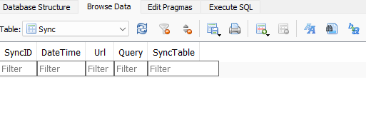
- Make any necessary backup of existing Kiosk App.
- Extract the files from the latest zip to the Kiosk App folder and replace existing files.
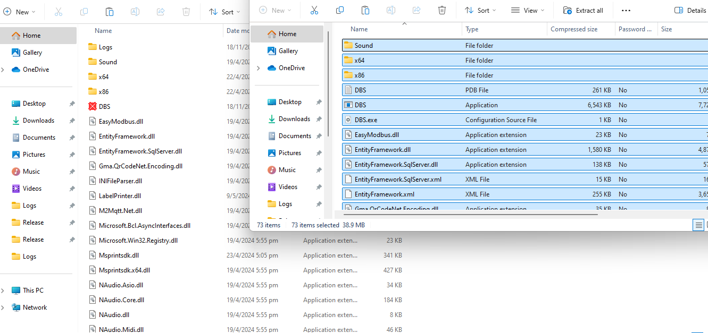
- Ensure that the Kiosk App folder contains tn.db3. If the file does not exist, obtain the tn.db3 file from the previous latest backup folder and copy it to the new Kiosk app folder.
- Update any shortcuts if necessary to ensure any backup versions are not run by accident.
- (Optional) To enable logging, create a Logs folder in the same folder as DBS.exe
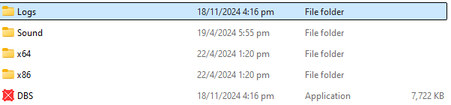
- Ensure that the latest version is now running.
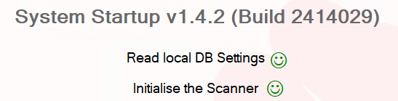

Deployment for Kiosk Server and SmartKiosk server
- Obtain latest zip files.
- Run the following commands to stop the current servers
  - pm2 ls to list the running instances.
  - pm2 stop # to stop both the mainserver and smartkiosk server.
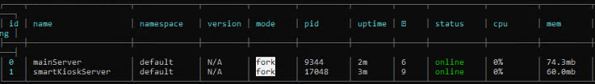
- Make any necessary backups.
- Extract the contents of server_build to the app server folder and replace the existing files.
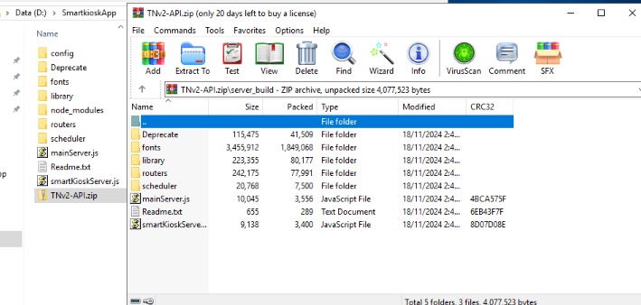
- Run pm2 restart # for both mainserver and smartkioskserver to resume their operation with the latest update.
- Run pm2 log # to ensure both servers have been successfully updated to the latest versions.
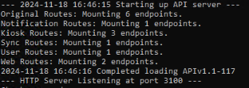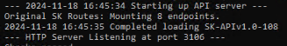
- Ensure that the Kiosk and Web Portal can access server.

